Sal f
Golden Valley High School
Wm. S. Hart Union High School District
“Home of the Grizzlies”
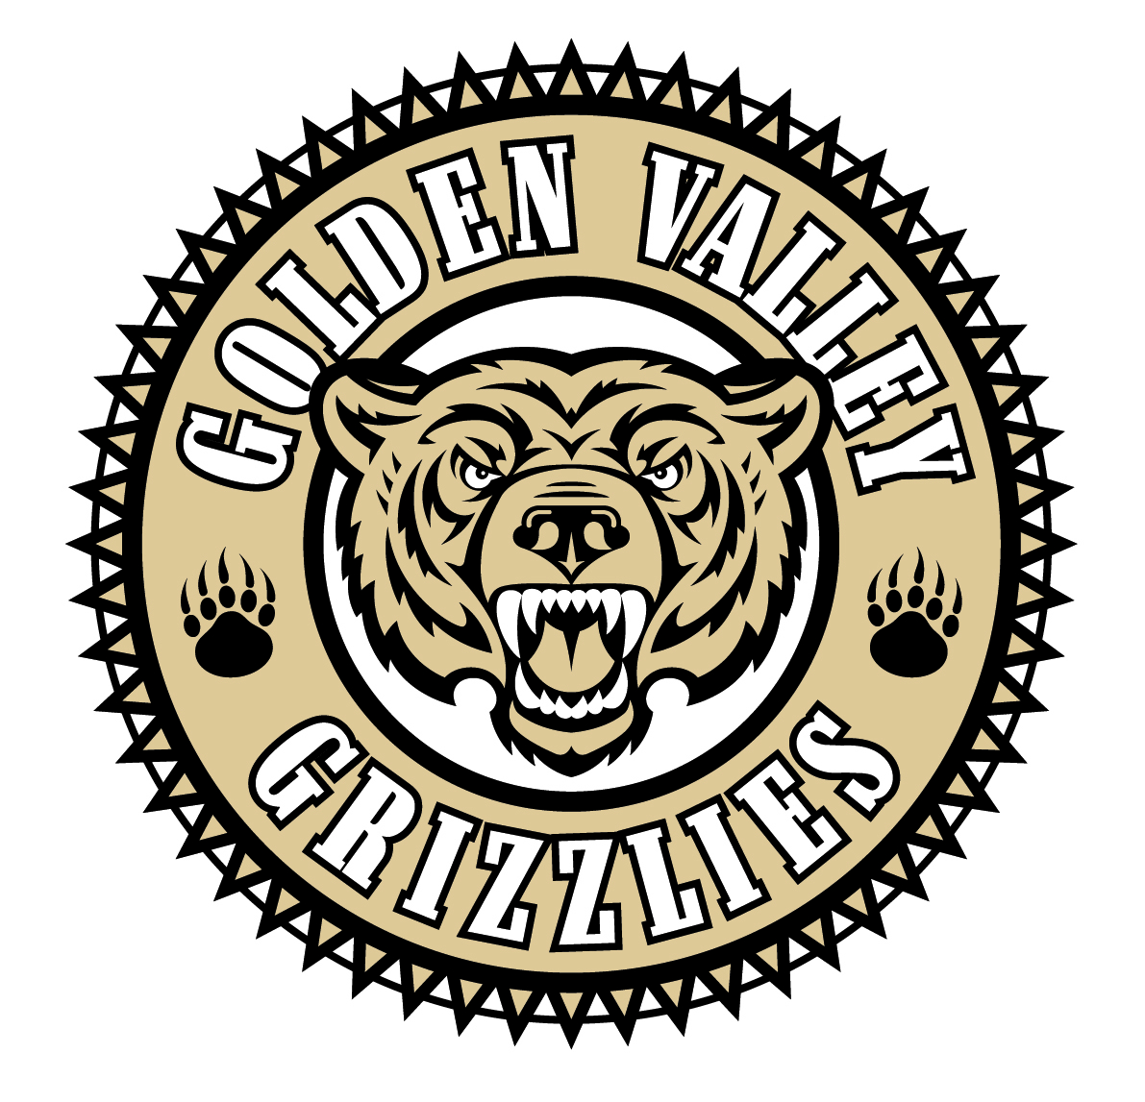
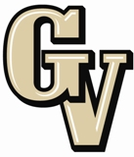

Parent Advisory Council (PAC) Meeting
September 23, 2013
6:30 PM

AGENDA

- PAC Meeting Welcome Sal Frias

- Secretary’s Report ACTION Jennifer Ryan

- Treasurer’s Report ACTION Emily Curtis

- President’s Report Sue Alterman

- District Advisory Council (DAC) Report Monica Camacho

- Parent Communications Council (PCC) Report Cherise Moore

- Common Core Sal Frias

- STAR & AP Results Sal Frias

- E Cigarettes Sal Frias

- Parking Lot and Traffic Pattern Update Sal Frias

- Western Association of Schools and Colleges (WASC) Sal Frias

Announcements: -GVHS Choir Soloist Recital – Thursday, Sept. 26th @ 6:30 pm in Theater
-Fall Break- October 7th and 8th. No School.
-Child and Family Center Kids Expo - Sunday, October 13th @ GVHS
-District Wide Common Core Parent Presentations (All at 6:30 pm)
-September 26 - Hart High Auditorium
-October 10 - Arroyo Seco MPR
-October 15 - Golden Valley Theater
-NHS Fall Induction – Wed., Oct. 16th @ 7 pm in Theater
-Homecoming Week Monday, Oct. 21st – 26th
-College Planning Experts – October 22nd at 6:30 pm in Library
-DTASC Scene Showcase – Thursday, Oct. 24th, 6:00 p m

Next Meeting: October 28, 2013

The mission of GVHS is to provide a quality education to a diverse student population, develop each student’s maximum potential, and prepare students for success in the global community.

